Installing Snowmobile Trail Maps for OsmAnd on Apple iPhones and iPads.

Start by downloading and installing the OsmAnd app from Apple App Store. The free version is all you need for trail riding.

1. Download OsmAnd_Snow_XX Maps from BackwoodsGPStrails.com
The downloaded zip file from our website contains several map and OsmAnd setup files and will ne named something like this OsmAnd_SNOW_NH_ME.zip, where SNOW indicates the sport, and the two letter abbreviations indicate the states included (NH=New Hampshire and ME-Maine) in this example.

2. Go to your Downloads Folder

3. Tap the .zip file which creates and extracts files into OsmAnd_Snow_XX folder

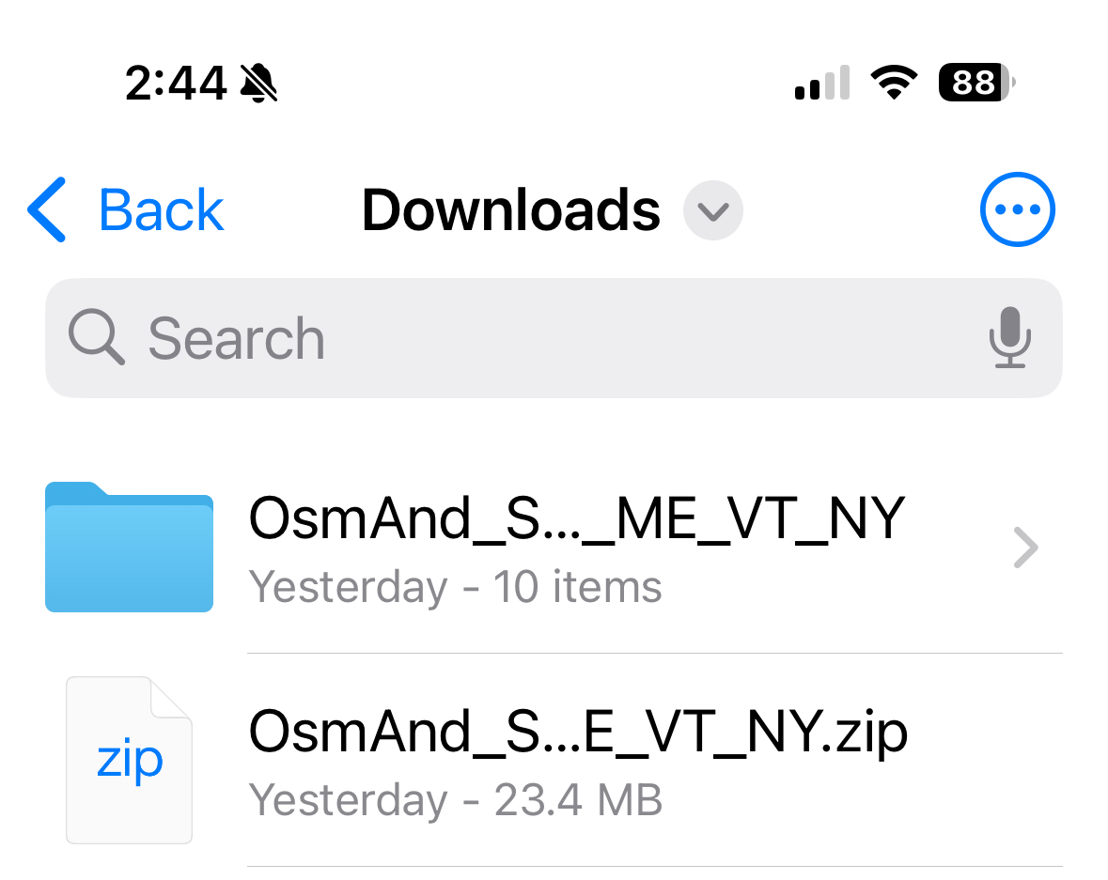

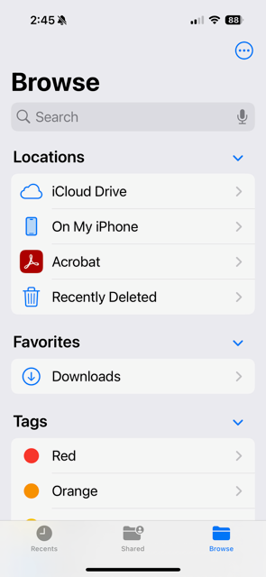

4. Move files from Downloads folder on iCloud Drive to On My iPhone

5.Open OsmAnd Maps folder and confirm files (.obf and .osf) are located there.

Offline vector map files (*.obf)

The files with .obf file types are offline map vector data files. These can be opened with the OsmAnd app to import the maps.
In the NH ME Snowmobile map example, we have four offline vector map files that are recognized as having an .obf file type. These are Places_NH.obf and Places_ME.obf contain seachable places in these two states, such as cities, towns, lakes, hamlets. These are optional, but are a nice way to quickly find knon recreational areas. SNOW_NH.obf and SNOW_ME,obf contains the snowmobile map data including trails, and searchable POI's relating to snowmobile trail riding, like hotels, parking restaurants near the trails.

Once .obf offline vector files have been extracted from the downloaded zip file, you will be able to simply click on them top open them using the OsmAnd app. This will import them into the app. You can then use the Downloads - Local Tab to activate the maps. Your Configure Map - Map Source should be set to display any activated offline vector maps.
.

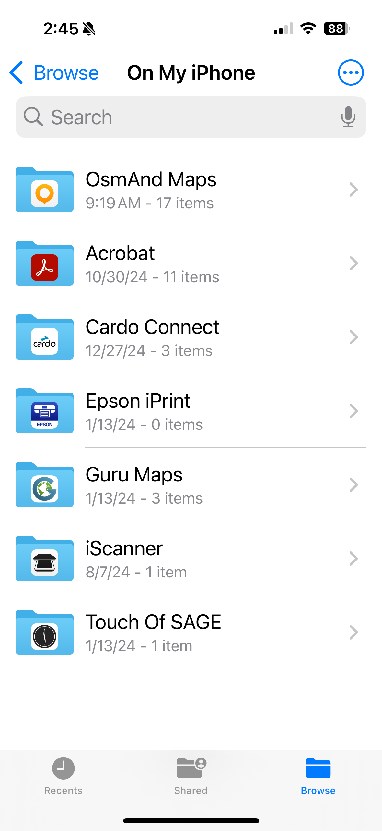
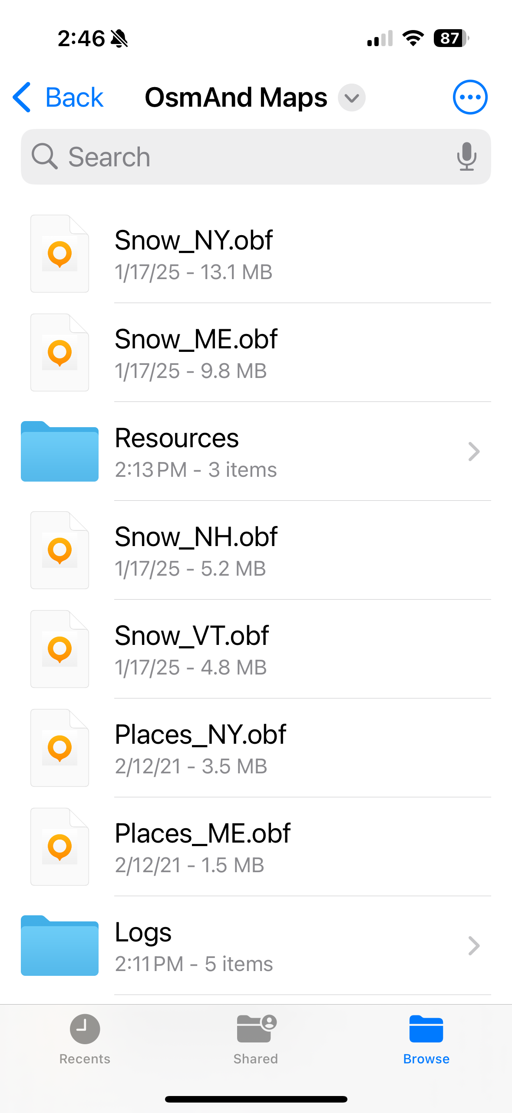

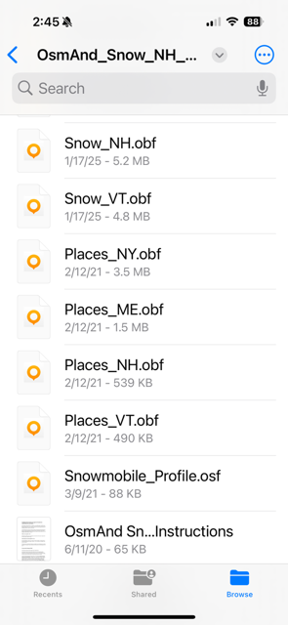

Files with the .obf file type are map files containing trails and or POI's.
Files with the .osf file type contain various settings and resources helpful for trail navigation.

6: Launch OsmAnd Maps App

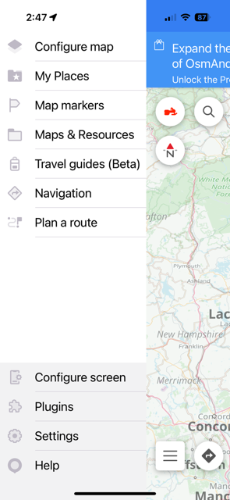

7: Go to settings and select Custom Profile - Snowmobile

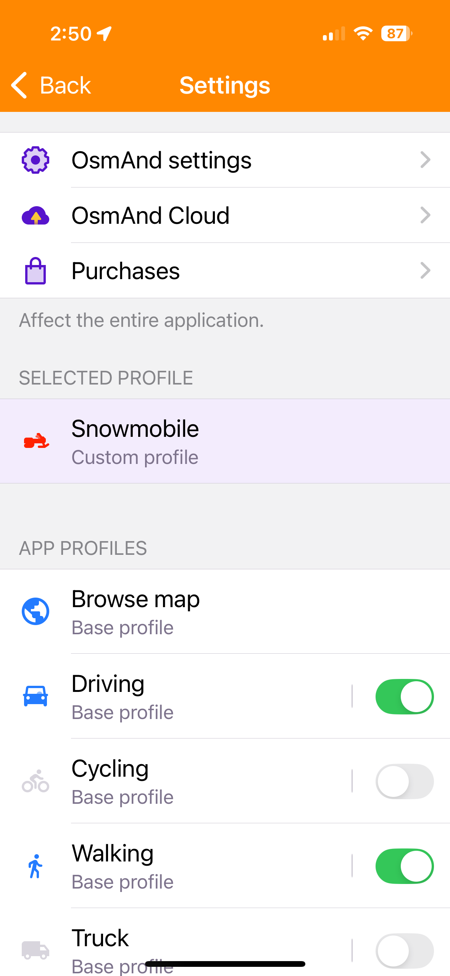

8: Select Navigate
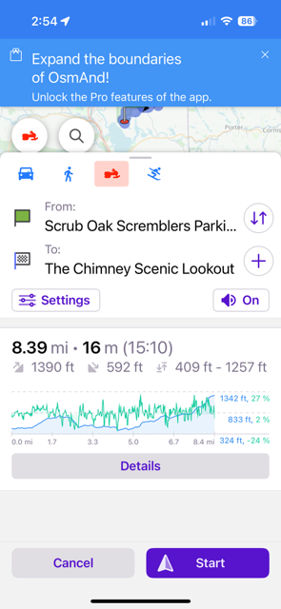

9: Enter From: and To: locations

10: Select Settings ( below To: location.)

11: Enable “Simulate Navigation”

12: Verify Navigation on Trails (not roads).

13. Remove non-trail maps if navigation goes on roads.

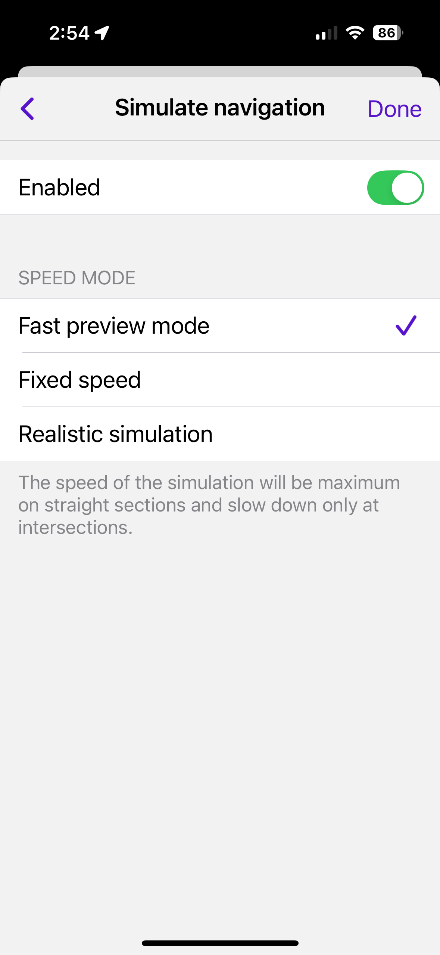

Usefull OsmAnd Features

Online Raster maps for use as Map Backgrounds

One of OsmAnd's coolest features is the wide selection of Online Raster (picture) maps. To enable getting online raster maps you must have Settings-Plugins-Online maps set to Enabled and its Settings use the internet checked.

While you are here, Trip Recording is another useful plugin to enable you to record tracks of your rides.

One of the most useful Online Raster map is Microsoft Hybrid. You can add this map to your list of available Online Raster maps by using Configure Map-Underlay map set to enabled and then select the Underlay map. If you see Microsoft Hybrid in the list then select it, otherwise you can find it in Install More.
Be careful with the setting of Base Map Transparency as if set incorrectly it can hide the trails shown on the vector maps.

I recommend having two types of Offline Raster maps for use as Background maps, a satellite image such as Microsoft Hybrid and a topographic map such as Open Topo or ERSI topo. You can pre-load these on your phone, and then switch back and forth as needed. These maps are setup when you open the Snowmobile_Profile.osf file from the downloaded ZIP file using OsmAnd. Just select all the items in the profile when asked. Overwrite old ones if you have used it before.

The newer format for Online raster maps can be imported from the AnyGis .sqlitedb files which is quite a bit easier (although ERSI topo is not included in that list).

Download the AnyGIS_Maps_Short_en.zip to your phone or computer. You will need to extract the files (or have a file manager that does automatically). You will then need to select the file that you want (E,g; Something.sqlitedb)

Pre-Loading Online Raster maps for use when you have no internet connection

Once you install .obf files they are fully on your phone and can be used without any internet or data connection. Online Raster maps on the other hand are only loaded from the internet as needed to fill in where you have scrolled and zoomed the map. Since a phone signal will not available in all remote locations, you will want to pre-load all the raster images that you may need on your ride. You can scroll around and zoom in where you will ride, but it's easier to use a feature to do it more automatically in one shot.
Use Configure map-Map source and set it to the Online Raster map (such as Microsoft Hybrid). Then return to the map display, Scroll the map to an area where you will be riding, and then zoom so the map screen displays all the area you want. The larger the area, the more storage required. Long click a pin on the map, then select Actions- Download map. Adjust the scroll bar to the maximum zoom level desired. The higher the zoom level, the more storage will be used and the more time it will take to download. DO THIS WHEN ON WIFI to avoid using up all your data plan bits. Repeat for any other Online raster maps you may want to use when out on the trails. Important: Once you have downloaded the raster maps you want, make sure to change the Configure Map - Map Source to Offline Vector maps. Otherwise the map will not be visible and you will not be able to route or search for service POIs.

Special Avoidances for Snowmobile trail maps

Ice Crossings - To avoid being routed across ice (which may be unsafe in early or late parts of the season) Setting - Snowmobile Profile - Navigation Settings - Route Parameters - Avoid Roads - No Toll Roads

Unmaintained Offtrail - Setting - Snowmobile Profile - Navigation Settings - Route Parameters - Avoid Roads - No Ferries

Exploring the capabilities of the OsmAnd App

It may feel like you have done a lot with OsmAnd, but you have just barely scratched the surface of its functionality. It's a complicated app. and takes time to master.

Here are some things that I think are worth exploring...
- Tracking and Track management.
- Attaching media, video, voice and photos to POIs you create on the map.
- Contour Lines Plugin (may cost a couple bucks)
- Shaded Relief
- Highway maps and navigation
- Avoiding specific roads and trails
- Different profiles settings.
- Quick action button. I use to switch between underlay maps. (included in Snowmobile_Profile.osf

The OsmAnd user group can be found here. You can get help from other OsmAnd Users...
https://groups.google.com/forum/m/#!forum/osmand

and

https://osmand.net/

